**Daily Scrum or Standup Meeting**

Team name: ________Group 2_________________

Scrum Master: ______Emily_________________

Date:________10/25_______________________

| **Team Member** | **What did you do since the last scrum?** | **What do you plan to do before the next scrum?** | **What obstacles do you have?** |
| --- | --- | --- | --- |
| Emily Thomas | Researched filtering by user group | Update user balances | Time |
| Karl | Made the user view dynamic | Work on user customize drink | a list of ingredients |
| Andre Nguyen | Closed to finishing the Menu Model Item | Have the Menu Model Item tested and linked to the drink item | Ran into errors with displaying the data |
| Maris Hurst | Refactored user model to include necessary properties (account balance and hours worked for employees) | Make myself available to help more | time? |
|  |  |  |  |

# Burndown

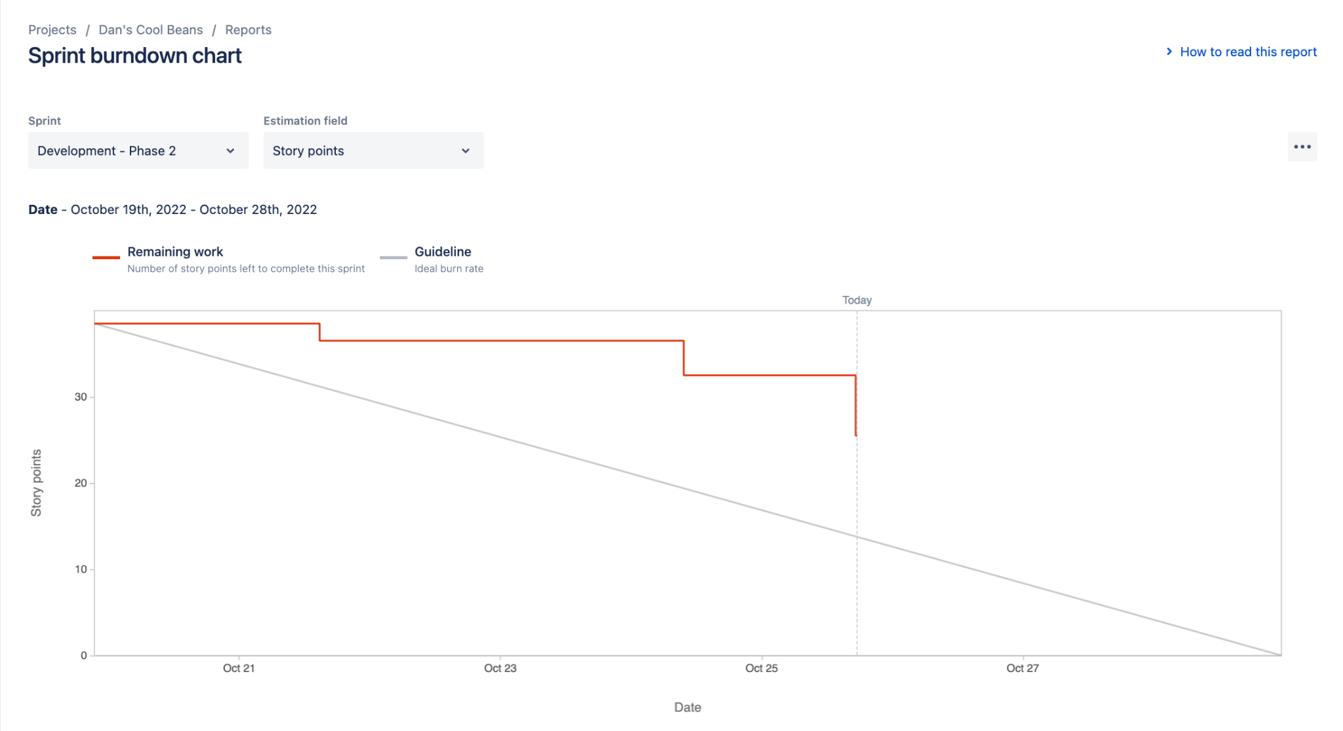

# Screenshot of you project board

